Setting Up the Unity Android Environment

There are many issues you will face when setting up any software that relies on other tools, plugins or software. This is no different. Below are steps to make sure your environment is setup to be able to build your Android projects.

* + - If you need to install it, install **Unity3D 2022.3.4**
    - Sign in, if you haven’t got an account, create one.
    - Create a new project and open it with the correct version of Unity3D (2022.3.4)
    - Click on **File** > **Build Settings**

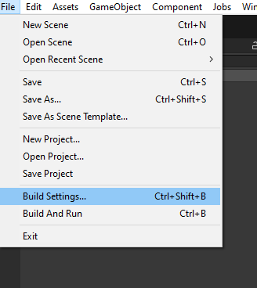

* + - Click on Android on the left-hand side, then click on Switch Platform.

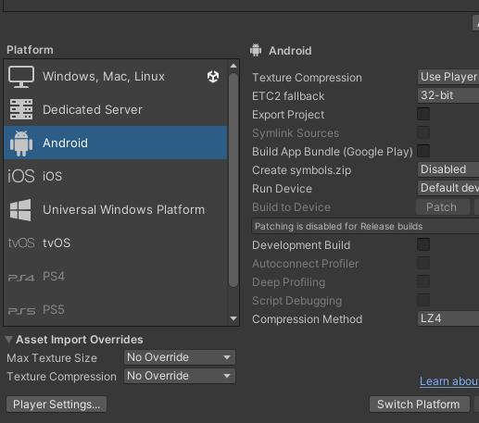

* + - Wait for Unity to reload.
    - Now we are going to make sure we can build. Click on **Build.**

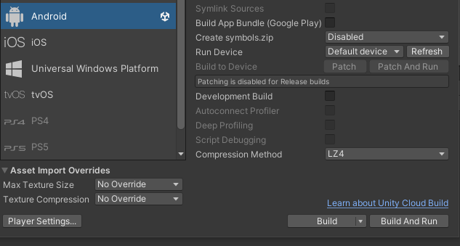

* + - Give your APK a name.
    - 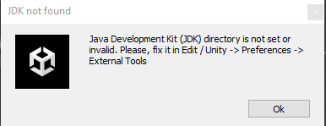If you get the following error (or similar JDK related),

go to the **LearningZone >Setting Up the Unity Android Environment > openjdk-11.0.1_windows-x64_bin.zip**. Download and extract to the D drive. (if its your own computer, place it anywhere that makes sense). **If there is an OpenJDK file(s) in the D drive, delete this folder.**

* + - 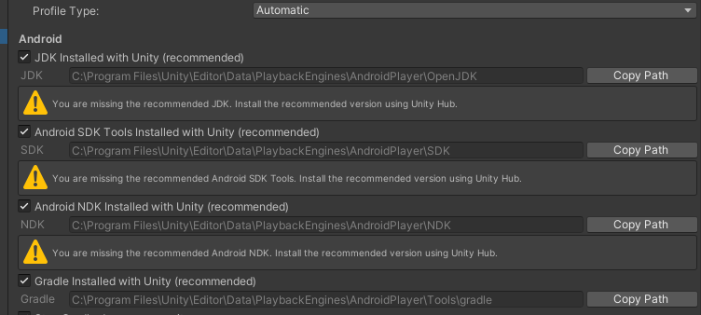Back to Unity, click on **Edit** > **Preferences** > (In new dialogue) **External** **Tools**, and scroll down to the **Android** section.
    - Uncheck the **JDK Installed with Unity** option, then **Browse** to the OpenJDK folder you just extracted and select it.

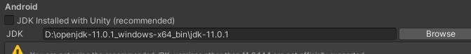

* + - Try build again.
    - 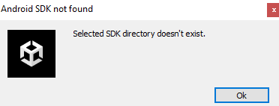If you get the following error (SDK related), we have to make more changes.
    - Open up **Android Studio** 2022.2.1 Patch 2. **If you’re on a personal computer then you will need to install it.**
    - Click on **More** **Actions**, then **SDK** **manager**

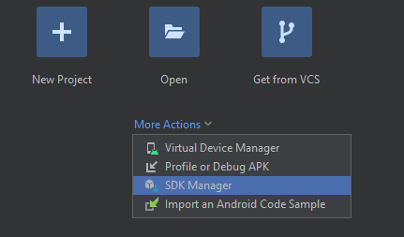

* + - In the SDK Manager, click on **Android** **SDK** on the left, then click on **SDK** **Tools**, then click on **Show** **Package** **Details**.

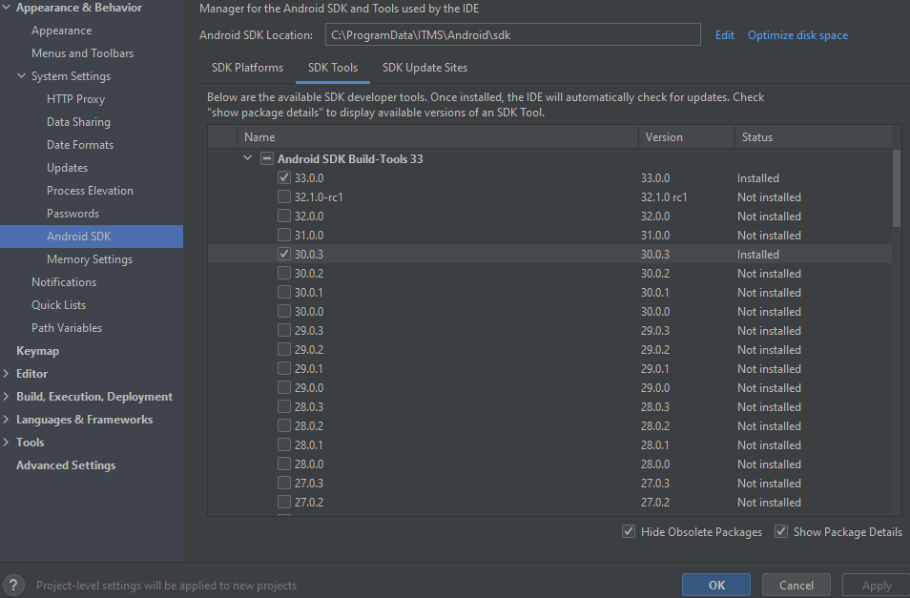

* + - You need to install the following, by ticking them:
  + **NDK (Side by side) > 23.1.7779620**
  + **Android SDK Command-Line Tools > Android SDK Command-Line Tools (9.0).**
    - Once these have been ticked, click **Apply** and wait for download and install.
    - Once done, go back to **Unity3D** > **Edit** **Preferences** > **External** **Tools**, go to the SDK and NDK sections and uncheck the recommended checkbox and enter the path to the new installations. For the lab computers, it’s the following (**you will need to type it up as the folder is hidden**).

C:\ProgramData\ITMS\Android\sdk

C:\ProgramData\ITMS\Android\sdk\ndk\23.1.7779620

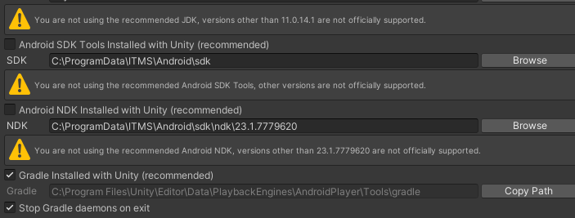

* + - Build again. If it is required restart the unity.